Regulations:
A18

H.T No

Sreenidhi Institute of Science and Technology
(An Autonomous Institution)
Code No: 7K201 Date: 27-Jan-2020 (FN)

B.Tech I-Year II-Semester External Examination, Jan/Feb-2020 (Supplementary)
ENGINEERING MECHANICS FOR CIVIL ENGINEERING (CIVIL)

Time: 3 Hours Max.Marks:70

Note: a) No additional answer sheets will be provided.
b) All sub-parts of a question must be answered at one place only, otherwise it will not be valued.
c) Missing data can be assumed suitably.

Part - A Max.Marks:20

Answer all QUESTIONS.

1. | Define Static Indeterminacy. | [2M]
2. | What are the different types of friction? | [2M]
3. | Define centre of gravity? | [2M]
4. | What is the energy equation for equilibrium? | [2M]
5. | Define Newton’s second Law. | [2M]
6. | What are the different types of motion? | [2M]
7. | What do you meant by equilibrium of forces? | [2M]
8. | What do you meant by mass moment of inertia? | [2M]
9. | Define kinetics. | [2M]
10. | What are the different methods of analysis of trusses? | [2M]

Part – B Max.Marks:50
ANSWER ANY FIVE QUESTIONS. EACH QUESTION CARRIES 10 MARKS.

11. |  | A parallel force system acts on the lever shown in Fig.. Determine the magnitude and position of the resultant.  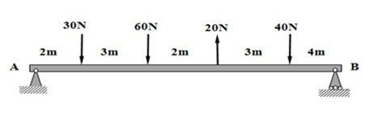 | [10M]
12. |  | A uniform ladder 4.8 m long and weighing W Newtons is placed with one end on the ground and the other against a vertical wall. The angle of friction at all contact surfaces is 20°. Find the minimum value of the angle θ at which the ladder can be inclined with the horizontal before slipping occurs. | [10M]
13. |  | From a rectangular cross section, 80 mm wide and 100 mm high, two semi circular portions of each 60 mm dia. are removed as shown in fig.. Determine I_{xx} and I_{yy} for the cross section.  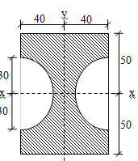 | [10M]
14. |  | Explain virtual work with an example. | [10M]
15. |  | A body weighing 300 N pushed up at 30ºplane by a 400 N force acting parallel to the plane. If the initial velocity of the body is 1.5 m/s and co-efficient of kinetic friction is0.2, what velocity will the body have after moving 6 m? | [10M]
16. |  | A pile having a weight of 5000 N is driven into the ground by dropping a hammer of Weight 3180 N at a height of 2.7 m. The pile is driven into the ground by 0.15. Calculate the average resistance of the soil. | [10M]
17. |  | Using the method of joints find the forces in all the members of the truss loaded as shown in figure  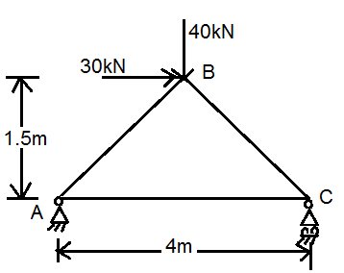 | [10M]
18. |  | Derive the expression for mass moment of inertia of the sphere whose radius is ‘r’ about its centroidal axis by using first principles. | [10M]

-- 00 -- 00 –

